**Security Group And NACL Examples from AWS Lesson**

**NACL**

**Web-traffic**

**Database-traffic**

**Security Group**

**Web-server**

Accepting internet traffic

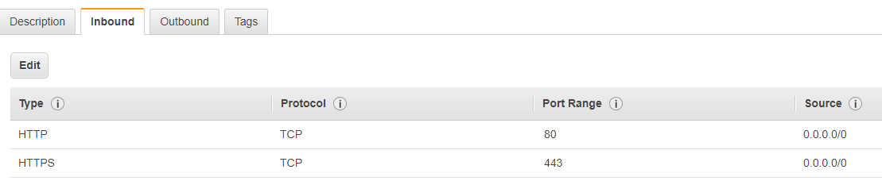

**Ssh**

Accepting SSH from my computer

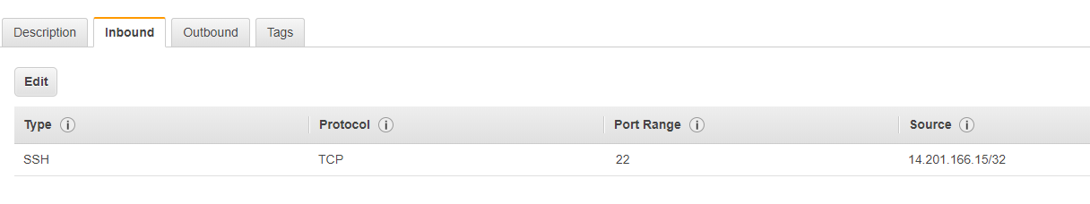

**Database-server**

Accepting traffic on port 5432 from Subnet A (10.2.0.0.24)

